typedef enum TeTypeCode {

  TC_REF_TOMBSTONE          = 0x0,

  TC_REF_INT32              = 0x1, // 32-bit signed

  TC_REF_FLOAT64            = 0x2, // 64-bit float

  TC_REF_STRING             = 0x3,

  TC_REF_INTERNED_STRING    = 0x4,

  TC_REF_FUNCTION           = 0x5, // TsBytecodeFunc

  TC_REF_HOST_FUNC          = 0x6, // TsHostFunc

  TC_REF_UINT8_ARRAY        = 0x7, // Byte buffer

  TC_REF_SYMBOL             = 0x8, // Reserved: Symbol

  /* ------------ Container types ------------------ */

  TC_REF_DIVIDER_CONTAINER_TYPES,  // <--- Marker

  TC_REF_CLASS              = 0x9, // TsClass

  TC_REF_VIRTUAL            = 0xA, // Reserved: TsVirtual

  TC_REF_RESERVED_1         = 0xB, // Reserved

  TC_REF_PROPERTY_LIST      = 0xC, // TsPropertyList

  TC_REF_ARRAY              = 0xD, // TsArray

  TC_REF_FIXED_LENGTH_ARRAY = 0xE, // TsFixedLengthArray

  TC_REF_CLOSURE            = 0xF, // TsClosure

  /* -------------- Value types -------------------- */

  TC_VAL_INT14              = 0x10,

  TC_VAL_UNDEFINED          = 0x11,

  TC_VAL_NULL               = 0x12,

  TC_VAL_TRUE               = 0x13,

  TC_VAL_FALSE              = 0x14,

  TC_VAL_NAN                = 0x15,

  TC_VAL_NEG_ZERO           = 0x16,

  TC_VAL_DELETED            = 0x17,

  TC_VAL_STR_LENGTH         = 0x18, // The string "length"

  TC_VAL_STR_PROTO          = 0x19, // The string "__proto__"

  TC_END,

} TeTypeCode;

typedef enum vm_TeWellKnownValues {

  VM_VALUE_UNDEFINED     = 0x0001,

  VM_VALUE_NULL          = 0x0005,

  VM_VALUE_TRUE          = 0x0009,

  VM_VALUE_FALSE         = 0x000D,

  VM_VALUE_NAN           = 0x0011,

  VM_VALUE_NEG_ZERO      = 0x0015,

  VM_VALUE_DELETED       = 0X0019,

  VM_VALUE_STR_LENGTH    = 0X001D,

  VM_VALUE_STR_PROTO     = 0x0021,

  VM_VALUE_WELLKNOWN_END,

} vm_TeWellKnownValues;

# Short Pointer

# 

# Bytecode Pointer

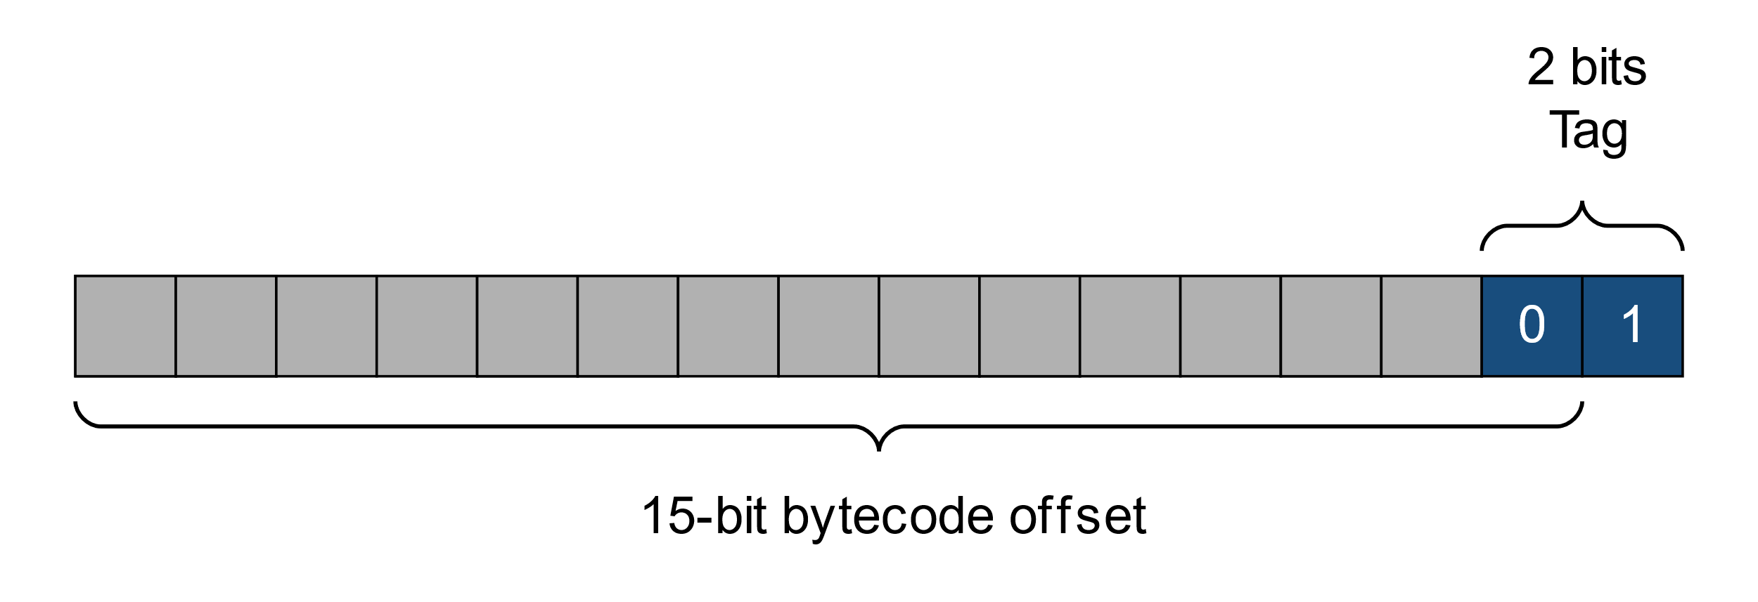

# Int14

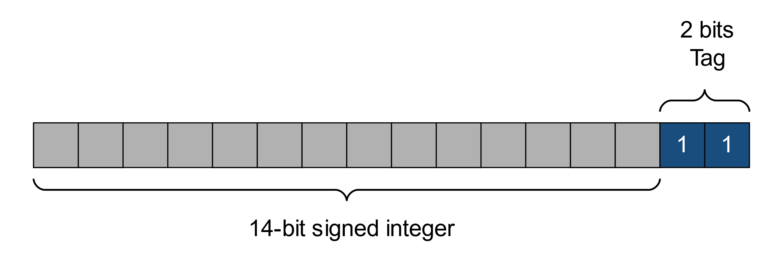

# Header word

